Donations  Most needed items  We provide like-new, in-style clothing and essentials to families in need. |  |  | 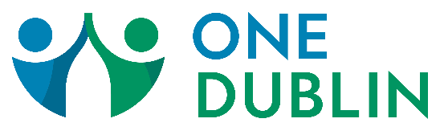
Drive-Thru  Donation Day |  | First Saturday of every month. Please check the website at one-dublin.org to make sure we are having one |  |  |  | 9:00 am-11:00 am  Parking lot of Indian Run United Methodist Church  6305 Brand Road, Dublin 43016
Spring/summer clothes  - Size 5T Clothing (boy & girl)  - Children’s Dresses (all sizes)  - Spring Jackets (infant-18 mo)  - Children’s Clothes (14 boy & girl)  - Teen Clothing (all sizes)  - Maternity Clothes  - Men’s Spring Shirts (especially size S, M)  - Men’s Athletic Wear (especially size XS, S, M)  - NEW Women’s Underwear (size S)  - Bras/Sports Bras (preteen & women)  - Shoes (children’s and men’s) |  | Personal care  - Shampoo  - Conditioner  - Bodywash  - Razors (men and women)  - Baby Shampoo  - Baby Wash  - Baby Lotion  - Pull Ups |  |  |  | household items  - Bath Towel Sets  - Sheets (all sizes, especially queen & king)  - Comforters (all sizes, especially queen & king)  Fun to offer items  - Purses  - Wallets  - Umbrellas  - Ponchos/Rain Coats  - Beach Towels
We accept clean, gently-used clothing and personal care items. We appreciate items that are more outgrown then outworn. Socks, underwear and personal care items must be NEW.

Ask yourself, “Would I give it to a friend?”

Donations should be removed from hangers and placed in plastic bags for donation drop off day. Labeling your donation bags makes it easier for us to sort!

Thank you for your donations!!!

