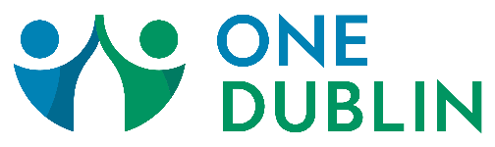
ESL (English as a Second Language) Resources

Name | Program | Website | Phone
ABLE (Adult Basic and Literacy Education) | Free English classes for individuals 18+ who do not have an F1 Visa | eastland-fairfield.com/aspire | 614.836.4541, ext. 1403 (daytime)  614.836.4541, ext. 1659 (evening)
Asian American Community Center | English courses for beginner and intermediate levels | aacsohio.org/classes | 614.220.4023 ext. 230
Church of the Redeemer | Free ESL classes. All levels taught | redeemermoravian.org/ministries/esl | 614.766.5030
Coffee and Conversation at Northwest United Methodist Church | Basic communication to practice English. Thursday mornings | nwumc.com/coffeeandconversation | 614.451.2825
Dominican Learning Center | Learn to read, write, understand and speak English | domlearningcenter.org | 614.444.7330
Dublin Baptist Church | Classes that range from beginner classes to intermediate to more advanced | dublinbaptist.com/ministries/outreach | 614.889.2307
Columbus State Community College | Low-cost non-credit Basic ESL classes for beginning to high intermediate English learners | cscc.edu/community/language-institute/ | 614.287.5858
FESTA | 3-Generation Family ESL | wearefesta.org | 614.586.7939

